John Humphreys

IT FDN 100 A

Module 6 Assignment

05 November 2017

This assignment builds from Assignment 5, which was a Python script that reads from and writes to a “To-Do” list in a text file. I refactor the script from Assignment 5 here, using one class containing methods for the respective options. This moves processing found in the “Presentation” block in Assignment 5 to the “Processing” block in this Python script. It also encapsulates the processing.

a) First step was to create PyCharm file template.

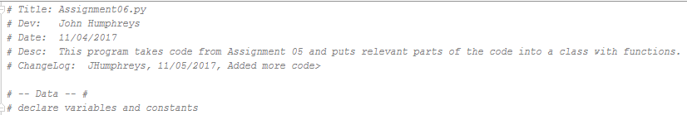

b) Second step was copying reusable code from Assignment 5.

here…

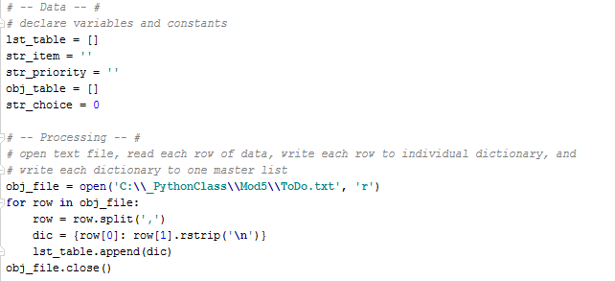

and here:

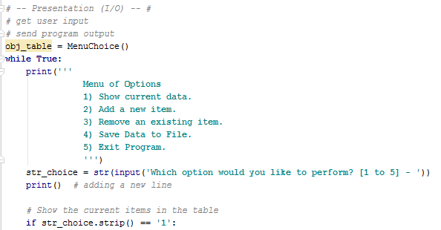

c) In third step, I created a class called "MenuChoice" with methods that accomplish the operations for each of the respective menu options in the "while" loop.

The methods were made reusing code from Assignment 5. Here is an example of how they turned out.

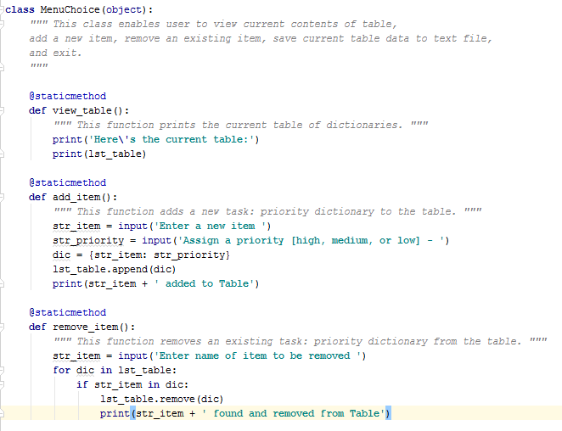

d) Final step was to refactor the "Presentation" block. I instantiated a "MenuChoice" object called "obj_table" and placed code to call the relevant "MenuChoice" method, using "obj_table", to accomplish the respective menu operation.

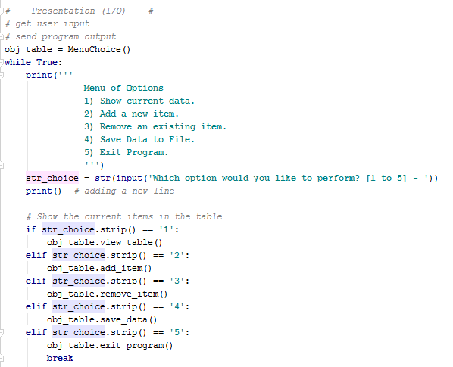

Thus, this assignment enabled me to learn how the use of methods within a class can better optimize abstraction of a Python script. It also elegantly demonstrated the power of encapsulation to remove processing tasks from the "Presentation" block.